Custom STAR-CA Flyer Instructions
- Add campus learning center contact information (in top right corner) for students with questions
- Insert your school logo (may need to confirm permission with your institution’s PR team) by replacing box in top left corner and make sure it has alt text
- Delete this instructional page
- Save as a PDF
- Check that the PDF is accessible (usually need to change Starting View to use Title)
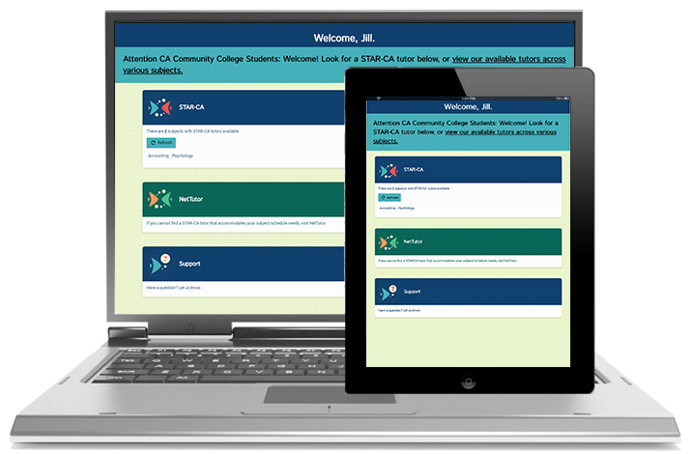
œœttRtttbtt
STAR-CA

Find more information at www.star-ca.org.
SUBJECTS
Algebra
College Algebra
Precalculus
Calculus I-III
Statistics
- Log into Canvas
- Go into any course

- Click on the “Tutoring” or “NetTutor” tab

- CA Community College students can work with CA Community College tutors by clicking the top option when they see STAR-CA tutors available!

- Schedule is at www.star-ca.org/#schedule

FREE! ONLINE TUTORING WITH
FOR ACCESS TO
FREE ONLINE TUTORING
Biopsychology
Introduction to Psychology
Developmental Psychology
Psychology of Gender
Writing

Accounting
Principles of Economics
Introduction to Chemistry
General Chemistry I & II
Organic Chemistry
For more information,
please contact:
Contact Name
Contact Number
Contact Email
Replace this box with your school logo

